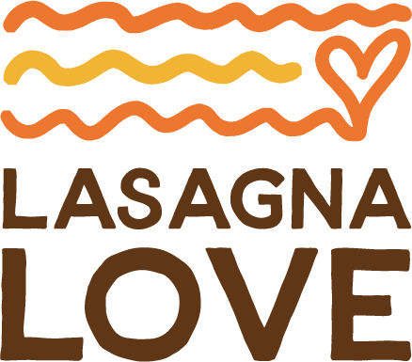

Cook food. Spread love. Strengthen communities.

Lasagna Love is a nationwide grassroots movement that aims to positively impact communities by connecting neighbors with neighbors through homemade meal delivery. It also seeks to eliminate stigmas associated with parents--especially moms--asking for help when it is needed most.

The COVID-19 pandemic has negatively impacted the lives of many at the very basic needs level. Food insecurity among children has skyrocketed. New responsibilities including distance-learning, maintaining COVID-safe practices and working remotely have further compounded the daily work already being shouldered by moms and head of households. Add to this a newborn baby, loss of a family member, or a household in which both parents work, and the struggle to get food on the table can feel insurmountable.

In an effort to alleviate some of the pressure, Rhiannon Menn, founder of Good to Mama and mother of two, started delivering homemade lasagnas to families needing a bit of care. While Good to Mama focused on helping moms be kinder to themselves, she saw an opportunity to be good to other moms during an unprecedented time of challenge. Her social posts offering help to moms not only garnered meal requests, they resulted in others moms and dads getting involved. In May 2020 “Lasagna Love” was born.

Lasagna Love exists to deliver comfort where we experience it most often—our family dining table - and to prove that even small displays of kindness can have profound and lasting impact. Our authentic mission is not only to help address the rise in food insecurity among families, but to also provide a simple act of love and kindness during a time of uncertainty and stress. We accomplish this by creating an easy and accessible way for every person to help a neighbor in need in a way that is comfortable and meaningful for them. Lasagna Love today delivers, on average, upwards of 3,500 meals a week across the country.

Lasagna Love spans the entirety of the United States — currently reaching all 50 states, more than 1,000 cities (including major metros: Atlanta, Boston, Chicago, Dallas, Houston, Las Vegas and San Diego) and is powered by more than 20,000 volunteers. Lasagna Mamas and Papas are matched weekly with neighbors in need to whom they deliver custom meals and sometimes additional care packages.

Get involved:

- Anyone can volunteer to be matched with a family in need. Families previously supported by Lasagna Love have even signed on as volunteers and are today paying it forward to other families in their community. We encourage every member of the family to play a role--shopping for ingredients, cooking, preparing and delivering meals.

- By serving those directly in our immediate community, Lasagna Love is purposeful. Volunteers know to whom they are gifting a meal and recipients know from where their meal came. This model ensures that each participant experiences the impact of giving and receiving--a memory they will forever cherish.

- There is no commitment or expectation for giving. If a volunteer or family can deliver one lasagna or a salad, it is a welcome gift. If they can do more, Lasagna Love can match them with several families needing support. Lasagna Love members are both humbled and grateful for every level of support received.

- Lasagna Love is an all volunteer-run social impact movement of kindness that has grown exponentially in just a few short months. We welcome extra pairs of hands as well as donations from individuals and local businesses that have interest in helping us extend our reach.

- Lasagna Love established a monthly sponsorship program through which families can donate either to support operations or pay for groceries for our volunteers who are able to make big batches but can’t afford ingredients. Lasagna Mama cooks can place your family or business name on the delivery so the recipient family knows whose generosity made this possible.

- Lasagna Love doesn’t only make lasagnas (many are made specific to dietary needs, allergies or restrictions), volunteers have also delivered salads, sides and desserts to round out a healthy meal. Volunteers determine what they want and can afford to do for the community members with whom they are matched.

- If a business (local/regional or national) wishes to support Lasagna Love, we welcome support in the form of financial donations. We have established promotional vehicles to highlight our partners and brand collaborations through branded delivery letters. We hope to expand options in the near future.

- Lasagna Love volunteers have graciously tailored deliveries--dietary restricted and allergy-friendly-- to the needs of each family.

- We welcome (and encourage) Lasagna Mamas and Papas to share with us their favorite lasagna recipes. We will soon post them to our website.
- To establish an additional funding source to support meal delivery to families in need, Lasagna Love established an online store in November through which Lasagna Love-branded merchandise including aprons, hats, face masks, onesies, stickers and car signs can be purchased. The additional funds go towards furthering the mission of Lasagna Love.

- In November 2020, Lasagna Love earned 501 (c) 3 non-profit status.

