MCVSD EDUCATOR Evaluation HANDBOOK:

Version iii
SEPTEMBER 2013

This document was compiled using guidance and source materials
provided by the MCVSD Teacher and Principal Pilot DEACs, documents
provided by Stronge and Associates, and documents developed, and
made available by, the Rhode Island Department of Education.
MCVSD gratefully acknowledges the contributions of these groups

TABLE OF CONTENTS

Teacher Evaluation p. 3-10
MCVSD Timeline for Teacher Evaluation: 2013-2014 p. 5
Weighting of Components: 2013-2014 p. 6
Weighting of Standards, with example p. 7
MCVSD Rubric for Evaluating SGOs: Standard 7 p. 8
MCVSD FAQs for Teacher Evaluation p. 9-10
Administrator Evaluation p. 11-19
MCVSD Timeline for Administrator Evaluation: 2013-2014 p. 13
Weighting of Components: 2013-2014 p. 14
Weighting of Standards, with example p. 15
State Rubric for Standard 3: Evaluation Leadership p. 16
MCVSD Rubric for Evaluating SGOs: Standard 7 p. 17
MCVSD FAQs for Administrator Evaluation p. 18

TEACHER EVALUATION

MCVSD Timeline for Teacher Evaluation: 2013-2014

Date (on or before) | Activity | Associated Documents | Responsible Person(s)
November 15 | Finalize student learning objectives | SGO Progress Form (current year) | Principal/Teacher
Sept-November | First observation of all non-tenured teachers  - 1 announced, with pre-conference  - at least one co-observation by Dec.1 | Formal Observation Form | Principal
Nov-January | 2nd observation of all non-tenured (NT) teachers  - at least one co-observation by Dec.1 | Formal Observation Form | Principal
January-March | 3rd observation of all non-tenured (NT) teachers  - second co-observation | Formal Observation Form | Principal
Sept-March | Required observations of all tenured teachers  - 1 announced, with pre-conference  - second co-observation | Formal Observation Form | Principal
March-April | Annual Summary Conference | Summative Evaluation form | Principal/Teacher
April-May | Annual Summary Conference | Summative Evaluation form | Principal/Teacher
November 15th (end of MP 1) | Teachers conduct 1st student survey | Student Surveys and Student Survey Summary form | Teacher
April 15th (end of PM3) | Teachers conduct 2nd student survey | Student Surveys and Student Survey Summary form | Teacher
Mid-Year | - Mid-Year review of SGO  - Documentation Log review (NT)  - Interim Performance Review (NT) | SGO Progress Form (current year),  Documentation log  Interim Performance Report | Principal  Principal  Principal/Teacher
10 calendar days prior to summative evaluation date | - Submit completed SGO Progress Form  - Documentation Log | SGO Progress Form/Documentation Log | Teacher  Teacher
June 1st | - Submit/Review projected SGOs and PDP plan (T/NT) | SGO Progress Form and district PDP form (summary of this year, goals for upcoming year) | Teacher/Principal

2013-2014
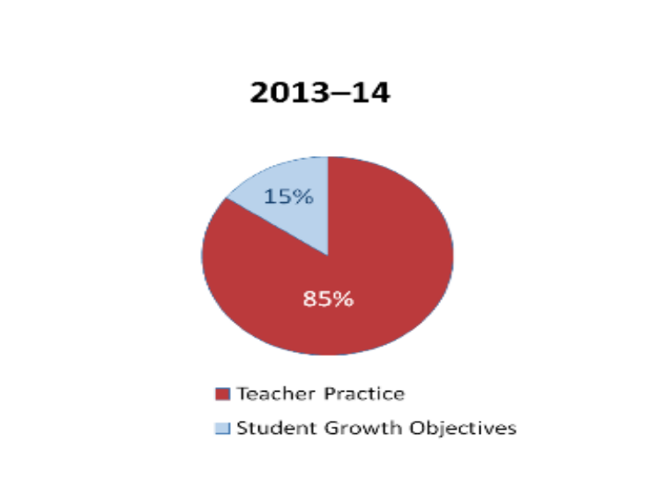
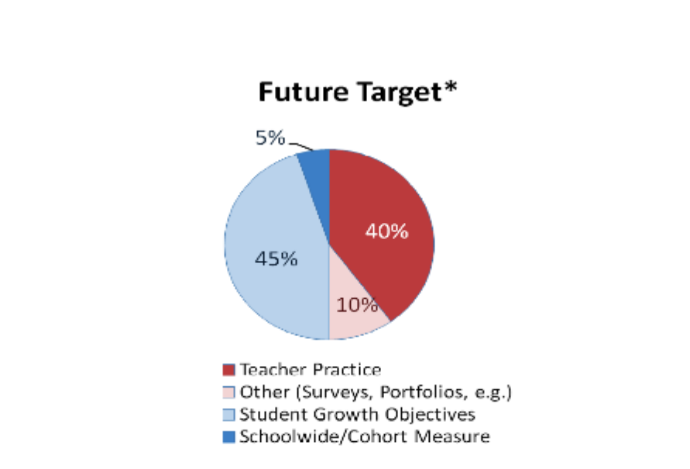
All

Teacher Evaluation: Teacher Practice Protocols (Observations)

Teacher Categories |  | Minimum # of Observations Required | Multiple Observers
Non-tenured | Years 1–2 | 3  (2 long, 1 short) | Required
Non-tenured | Years 3–4 | 3  (1 long, 2 short) | Required
Tenured | Effective  Highly Effective | 3  (0 long, 3 short) | Recommended
Corrective Action Plan |  | +1  (length at district discretion) | Required
•Long: 40 minutes, plus post-conference •Short: 20 minutes, plus post-conference
- 1 pre-conference for all teachers (matches up with an announced observation)

Weighting of Teacher Standards/Creating a Summative Score*: Example
Principal Performance Standard | Performance Rating | Quantified Performance Rating | Weight | Weighted  Contribution =  (quantified performance rating X weight)
Standard 1 | Effective | 3 | 14.2% | .426
Standard 2 | Effective | 3 | 14.2% | .426
Standard 3 | Effective | 3 | 14.2% | .426
Standard 4 | Effective | 3 | 14.2% | .426
Standard 5 | Effective | 3 | 14.2% | .426
Standard 6 | Highly Effective | 4 | 14.2% | .57
Standard 7 | Effective | 3 | 15% (SGOs: 7.5 each) | .45
 |  |  | Summative Rating  (Sum of weighted contributions) | 3.15*

*State Will Issue a Scale for Summative Evaluation Scoring Before 9/13

MCVSD Rubric* For SGO Evaluation (Standard 7)
(until superseded by a state issued rubric)

RATING | CRITERIA
Highly Effective | Evidence across all SGOs indicates exceptional student mastery or progress. All objectives are exceeded. This category is reserved for the educator who has surpassed expectations described in their Student Learning Objectives and/or demonstrated an outstanding impact on student learning.
Effective | Evidence across all SGOs indicates consistent student mastery or progress. All objectives are met. This category applies to the educator who has fully achieved the expectations described in their student learning objectives and/or demonstrated a notable impact on student learning.
Partially Effective | Evidence across all SGOs indicates inconsistent student mastery or progress. Some objectives may have been met or exceeded and other objectives not met, or all objectives have nearly been met. This category applies to the educator who has demonstrated an impact on student learning but overall has not met the expectations described in their SGOs.
Ineffective | Evidence across all SGOs indicates little student mastery or progress. Most or all objectives are not met. This category applies to the educator who has not met the expectations described in their SGOs and has not demonstrated a sufficient impact on student learning. This category also applies when evidence of the objectives is missing, incomplete, or unreliable or when the educator has not engaged in the process of setting and gathering evidence for Student Learning Objectives.

*Adapted from documents made available to the public on the Rhode Island Department of Education website: http://www.ride.ri.gov/educatorquality/educatorevaluation/Guides.aspx

FAQs for Teacher Evaluation

- What are the requisite artifacts for each standard? Bold are the required; below are suggestions for additional documents that could be used. This list is not intended to exhaustive or exclusive of others that teachers may want to use.
  - Standard 1: Professional Knowledge
    - PD Certificates
      - Activities/Directions for Students
      - Certification work
  - Standard 2: Instructional Planning
    - Lesson Plan: 1 Corresponding to the observation
  - Standard 3: Instructional Delivery
    - Evidence of Varied Instructional strategies
      - Instructional Resources
      - Sample Work or instructional activities
      - Video/Audio/Description Capture
      - Pictures
      - Evidence of Student Engagement (Skill Charting, Portfolio)
  - Standard 4: Assessment of and for Learning
    - 1 formative and/or 1 summative assessment: from the same unit as the lesson observed
  - Standard 5: Learning Environment
    - Student Survey Summary
  - Standard 6: Professionalism
    - 1 piece of evidence of stakeholder communication and/or product
(this could be an email, minutes, contact log, PLC notes, or sample of an end product.). Sample logs are in the Stronge Book
- How will a teacher attach a response to an electronic evaluation?
  - A teacher wishing to attach a response to the observation should type it into the comment box at the bottom of the form. If teacher does not wish to attach a response, please type no response in the comment box.

- Do teachers need to sign formal observations?
a. No signatures are required on observations. The date that you hit acknowledge is recorded on the observation. The summative evaluation will be printed and signed by both the administrator and the teacher.
- Do administrators need to submit hard copy of observations to central office?
  - No. Evaluators should hit the submit button on the bottom of the observation form at the time of the Post Conference. This will put an accurate date at the location currently called Date Completed. This location will be changed to say Post Conference Date but in the interim will be understood to reflect the date of the mandatory post conference.
- What should teachers do about PDPs?
A: In light of the new regulations released in August 2013, PDPs should reflect teachers' proposed SGOs for next year. The PDP form will be revised at the DEAC in the 2013-14 school year.
- Do teachers still have to complete the Professional Development Plan form at the end of the school year? A: Yes. Achieve NJ requires staff members complete a PDP form. If a staff member is rated partially effective or ineffective as a summative rating a Corrective Action Plan developed by the administrator and staff member will supersede the PDP form originally developed and submitted to the administrator.
- Must staff members include SGOs on their PDP form at the end of the school year? A: Yes. A minimum of two drafts SGO’s must be approved on the PDP form at the end of the school year. Those SGOs may be revised for final approval by November 15th. (The final approval date for SGOs in SY 2014-15 is expected to be October 15, 2014.)
- Can the PDP form be amended by a staff member who wishes to exceed the minimum number of SGOs as recorded on the PDP form or who has identified additional PD needs? A: Yes. The PDP form can be amended if a staff member wishes to include additional SGOs or has identified a professional development need requiring district resources. Any amended PDP must be approved by the administration.
- Will a staff member be rated “partially effective” or “ineffective” on their summative rating if they receive an ineffective rating on any one standard? A: No. With the current suggested rubric issued by the Stronge Evaluation System a single rating of ineffective or partially effective on ANY single standard will not result in an ineffective or partially effective summative rating because it is mathematically impossible. The NJDOE is expected to release an official rubric for summative ratings in September 2013.

10. What is required for a teacher or administrator to retain tenure?
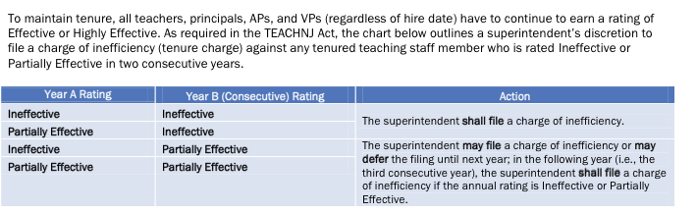

When is a CAP (Corrective Action Plan Implemented)?
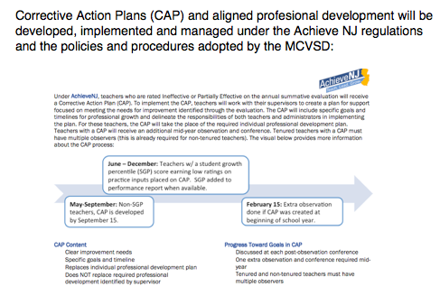
12. Will tenured teachers be evaluated by multiple observers? It is recommended that all teachers, including tenured teachers, be evaluated by multiple observers, but it is not required. Principals may utilize multiple observers for inter-rater reliability purposes (two observers at the same time, observing the same lesson), or may request that a second observer be used as an alternate to the building Principal for an observation. Any teacher being evaluated by two observers simultaneously will receive only one TPES Formal Observation Form, signed by the building Principal, as the teacher's official observation report.

13. Will all certificated staff members be required to have two SGOs? A. Yes, all certificated staff members in the district will have two SGOs.

ADMINISTRATOR EVALUATION

MCVSD Timeline for Administrator Evaluation: 2013-2014
Date (on or before) | Activity | Document | Responsible Person(s)
November 15th | Finalize student learning objectives | Student Academic Progress Goal Setting Form | Principal
Sept-November | Approx. dates for first observation of all non-tenured principals  - Post Conf.? | Formal Observation Form | Principal
Nov-January | Approx. dates for 2nd observation of all non-tenured (NT) principals  - Post Conf. | Formal Observation Form  Student Academic | Principal
January-March | Approx. dates for 3rd observation of all non-tenured (NT) principals  - Post Conf. | Formal Observation Form | Principal
Sept-March | Two required observations of all tenured principals  - Post Conf. | Formal Observation Form | Principal
November 15th (end of MP 1) | Principals conduct 1st teacher/staff survey | Teacher/Staff Survey Summary Form | Principal
December 1st | - at least one co-observation of a teacher completed
March 1st | - 2nd co-observation of a teacher completed
January 15th | Principals conduct self evaluation | Principal Self-Evaluation Form | Principal
April 15th | Principals conduct 2ndteacher/staff survey | Teacher/Staff Survey Summary Form | Principal
May 1st | Evaluators review Documentation Log | Documentation Log | Evaluator/Principal
June 1st | Principals submit completed section VII of goal setting form (End of year data results) for current school year | Student Academic Progress Goal Setting Form | Principal
June 1st | Principals submit goal setting form (sections I through V) for next school year | Student Academic Progress Goal Setting Form | Principal
By last week of school | Evaluators complete summative evaluations of the principals | Principal Summative Performance Report or Principal Interim/Annual Performance Review (as applicable) | Evaluator

Principal evaluation system for 2013-2014 will include the following components:

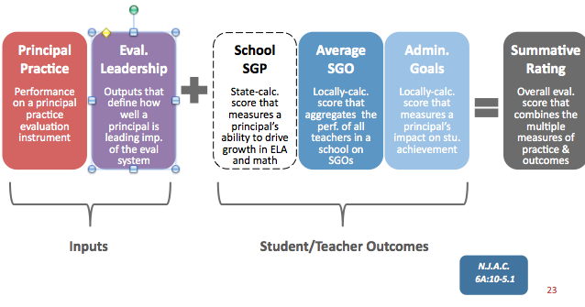

Weighting of Administrator Standards/Creating a Summative Score: Example
Principal Performance Standard | Performance Rating | Quantified Performance Rating | Weight | Weighted  Contribution =  (quantified performance rating X weight)
Standard 1 | Effective | 3 | 6% | 1.8
Standard 2 | Effective | 3 | 6% | 1.8
Standard 3 | Effective | 3 | 20% | .6
Standard 4 | Effective | 3 | 6% | 1.8
Standard 5 | Effective | 3 | 6% | 1.8
Standard 6 | Highly Effective | 4 | 6% | 2.4
Standard 7 | Effective | 3 | 50% (10% avg/40% Admin Goals) | 15
 |  |  | Summative Rating  (Sum of weighted contributions) | 31

Evaluation Leadership

20 percent of a principal’s score is based on a Leadership rubric. In 2013–14 the rubric measures how well the principal implements the new teacher evaluation system in his or her school. The rubric includes the following domains and components:

Leadership Rubric
Evaluation Leadership will be measured through performance on a state-provided rubric that highlights the importance of implementing the new evaluation system and the collaboration needed for its success. The rubric contains performance measures in the following categories:

Domain 1: Building knowledge and collaboration
- Component 1a: Preparing and training teachers for success
- Component 1b: Building collaboration
Domain 2: Executing the evaluation system successfully
- Component 2a: Fulfilling requirements of the evaluation system
- Component 2b: Providing feedback, coaching, and planning for growth
- Component 2c: Ensuring reliable, valid observation results
- Component 2d: Ensuring high-quality Student Growth Objectives (SGOs)

Leadership Rubric on Next Two Pages

￼￼
￼￼￼￼￼
￼

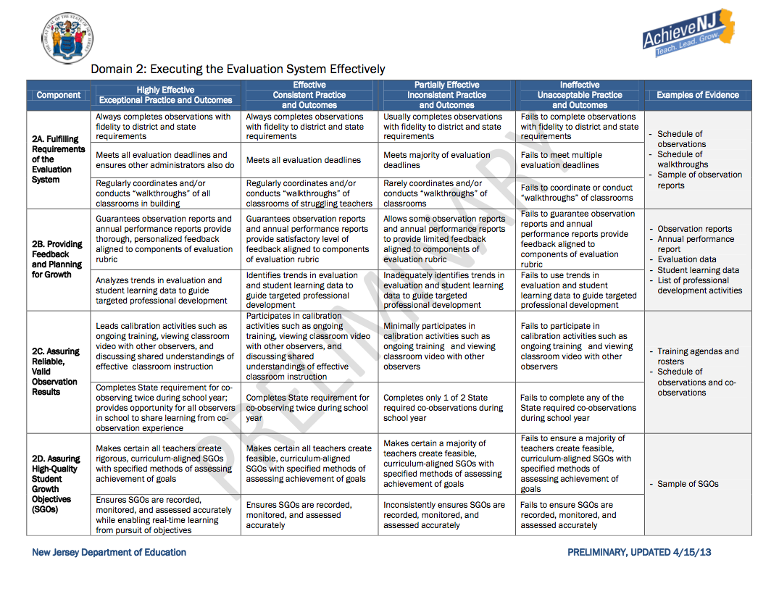
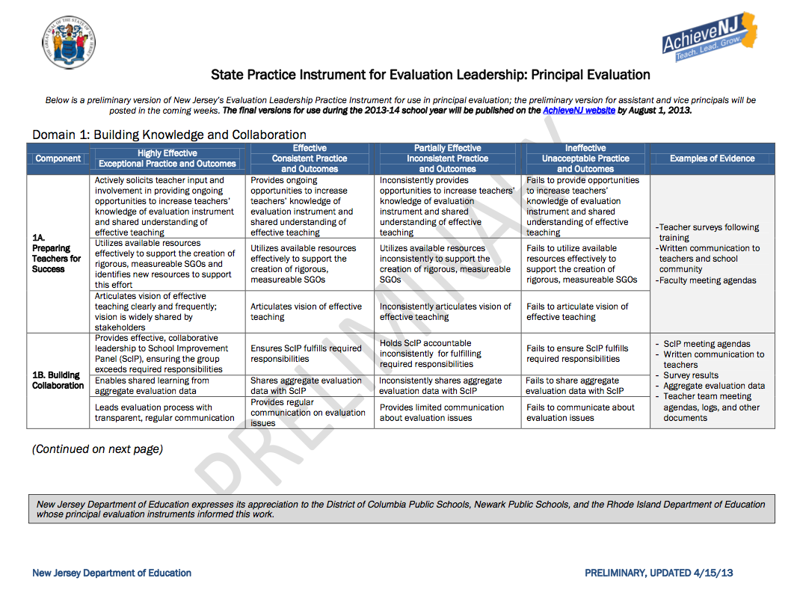

Rubric* For SGO Evaluation (Standard 7)
for Administrators (until superseded by a state issued rubric)

RATING | CRITERIA
Highly Effective | Evidence across all SGOs indicates exceptional student mastery or progress. All objectives are exceeded. This category is reserved for the educator who has surpassed expectations described in their Student Learning Objectives and/or demonstrated an outstanding impact on student learning.
Effective | Evidence across all SGOs indicates consistent student mastery or progress. All objectives are met. This category applies to the educator who has fully achieved the expectations described in their student learning objectives and/or demonstrated a notable impact on student learning.
Partially Effective | Evidence across all SGOs indicates inconsistent student mastery or progress. Some objectives may have been met or exceeded and other objectives not met, or all objectives have nearly been met. This category applies to the educator who has demonstrated an impact on student learning but overall has not met the expectations described in their SGOs.
Ineffective | Evidence across all SGOs indicates little student mastery or progress. Most or all objectives are not met. This category applies to the educator who has not met the expectations described in their SGOs and has not demonstrated a sufficient impact on student learning. This category also applies when evidence of the objectives is missing, incomplete, or unreliable or when the educator has not engaged in the process of setting and gathering evidence for Student Learning Objectives.

*Adapted from documents made available to the public on the Rhode Island Department of Education website: http://www.ride.ri.gov/educatorquality/educatorevaluation/Guides.aspx

FAQs for Administrator Evaluation:

- What are the requisite artifacts for each standard? Bold are the required; below are suggestions for additional documents that could be used. This list is not intended to exhaustive or exclusive of others that administrators may want to use.
              - Instructional Leadership: (6%)
                - Evidence of academic goal setting through professional conversations-
strategic plan, programs of study, focus on alignment
              - School Climate:
                - Teacher staff survey summary
              - Evaluation Leadership (20%)
                - Professional Development Plan
              - Organizational Management (6%)
                - Master Schedule
              - Communication and Community Relations (6%)
                - Meeting Agendas
              - Professionalism (6%)
                - Evidence of participation in professional activities
              - Students Progress (50%: 40% Admin Goals, 10% Avg. of Teacher SGO ratings)
                - Stronge goal setting form
            - Will the Mid-Year Review form or the interim Student Academic Progress Goal setting form be required for the 2013-14 school year?
              - These forms are not required by legislation.
            - When will Summative Conferences will take place
              - Before the end of the school year
            - How will SGOs results be matched up to an evaluation score?
              - See the rubric on p.8

